**Update Java**

Right click on AS-TestDriver 🡪Select Build Path 🡪 Configure Build Path

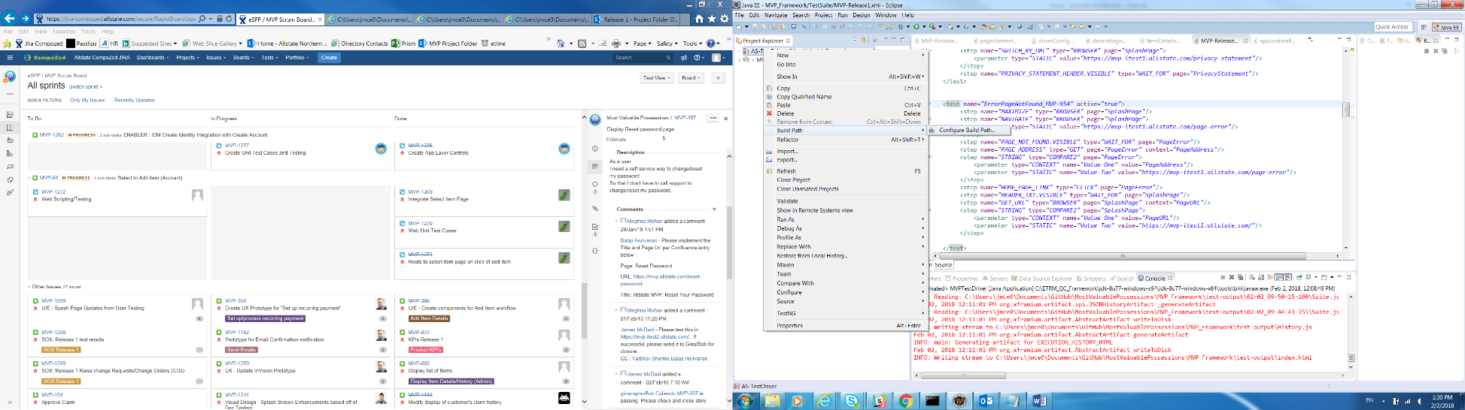

On the new dialog window click on the Libraries tab and click the Add Library button

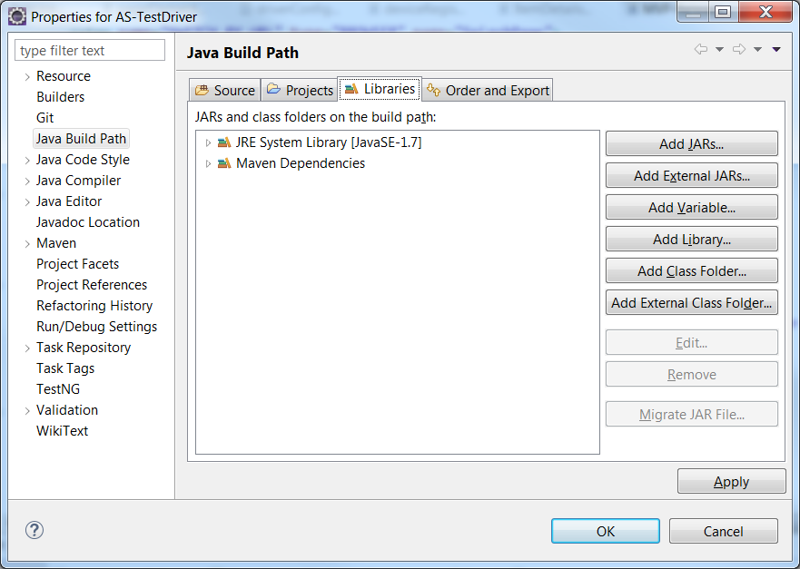

On the next dialog window select JRE System Library from the list and click next

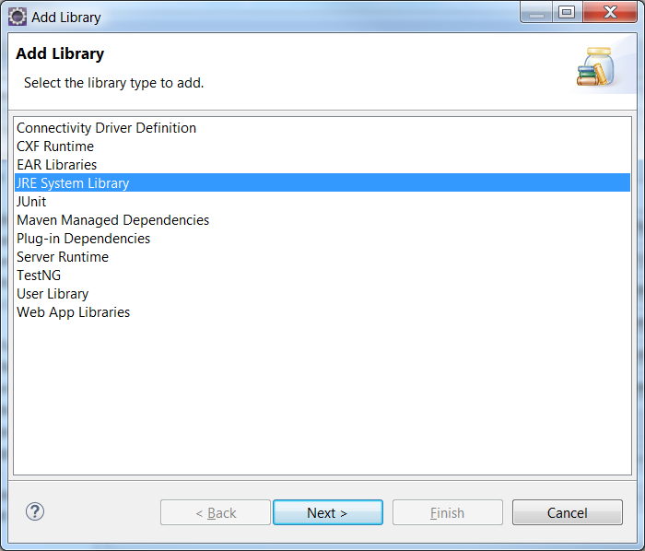

On the add library window click the Installed JRE’s button

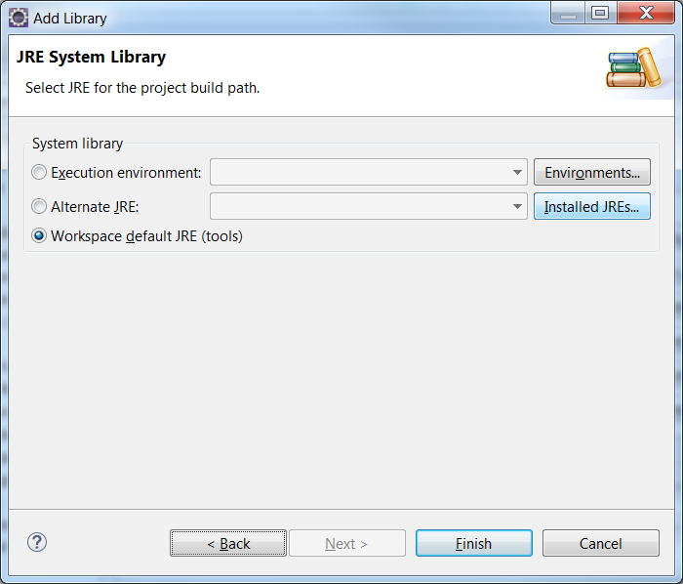

On the installed JRE’s window click Add button

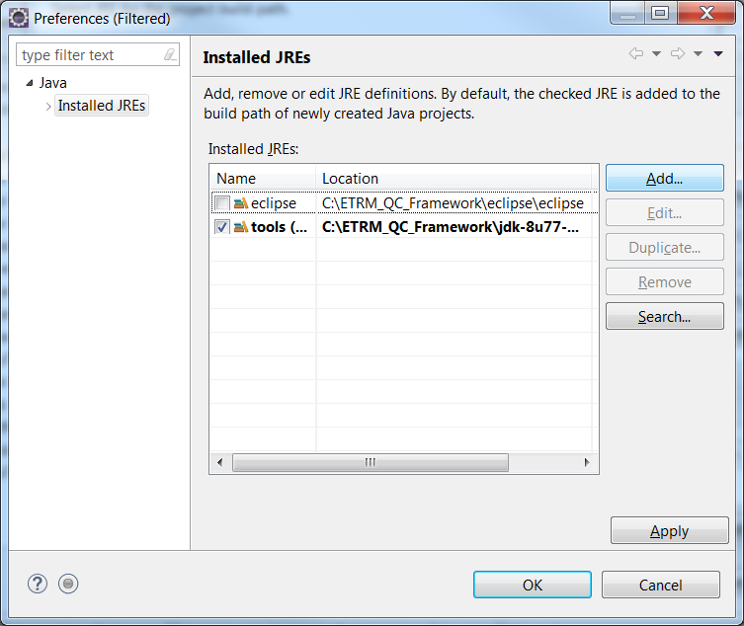

On the JRE Type window select Standard VM and click Next

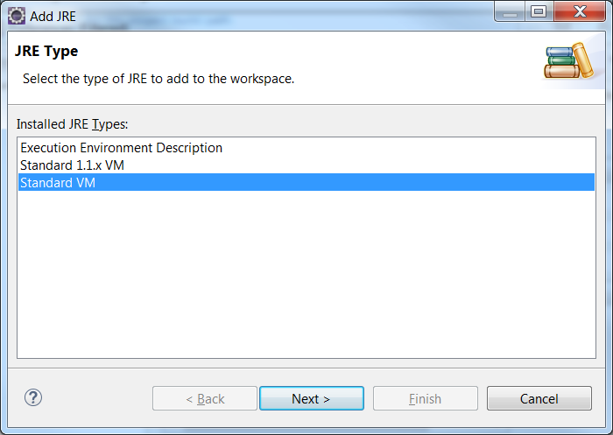

On the JRE Definition window click the Directory button

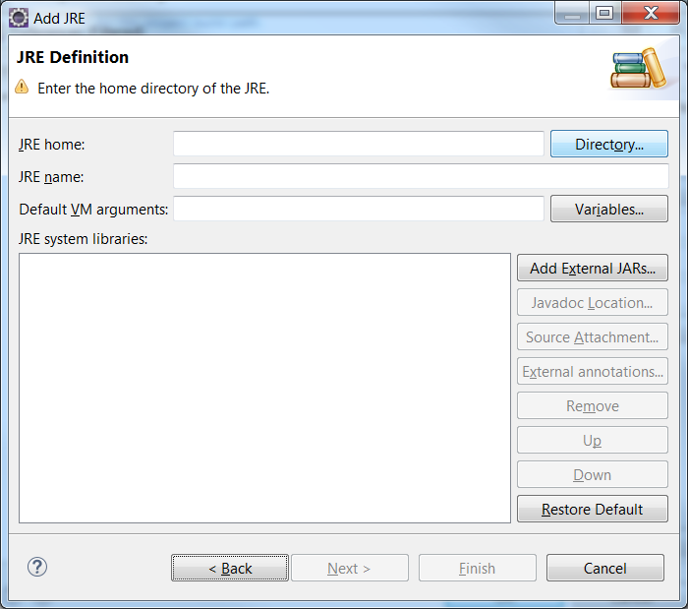

Browse to the location on your computer where you copied the framework files and navigate to jdk-8u77-windows-x64🡪jdk-8u77-windows-x64🡪tools

Click ok.

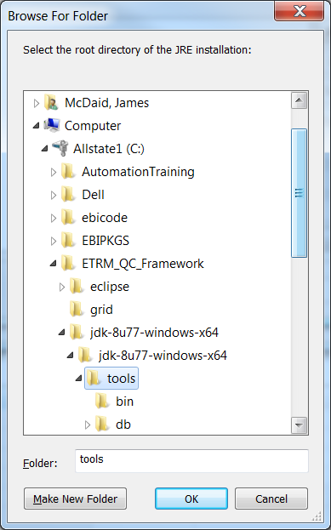

The JRE System Libraries should be populated with a list of files. Click Finish and the JRE Definition window will close

There should now be 2 entries in the Installed JRE’s window. Check the checkbox beside the tools entry and click Apply and OK

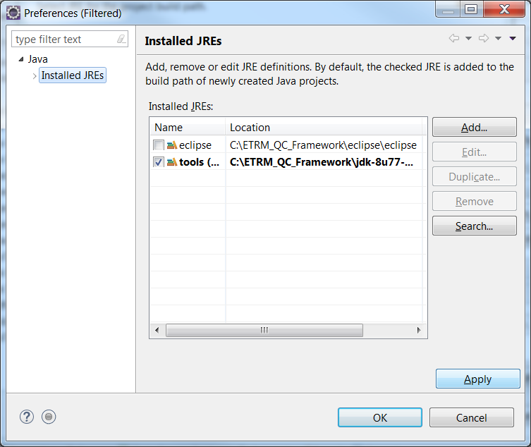

When you get back to the Java Build Path window select the 1.7 JRE System library and click the remove button. This should leave you with just the JRE System Library (tools)

